Lab 10 Design and Analysis of Algorithms

Name: Tanvi Penumudy

Enroll No: E18CSE187

Batch: EB06

**Implementation of Floyd-Warshall’s Algorithm**

**Question 1:**

The number in cell (i,j) denotes the cost of the edge between i and j. Further, ∞ denotes there is no edge between the corresponding vertices.

Given Adjacency Matrix for Weighted Directed Graph:

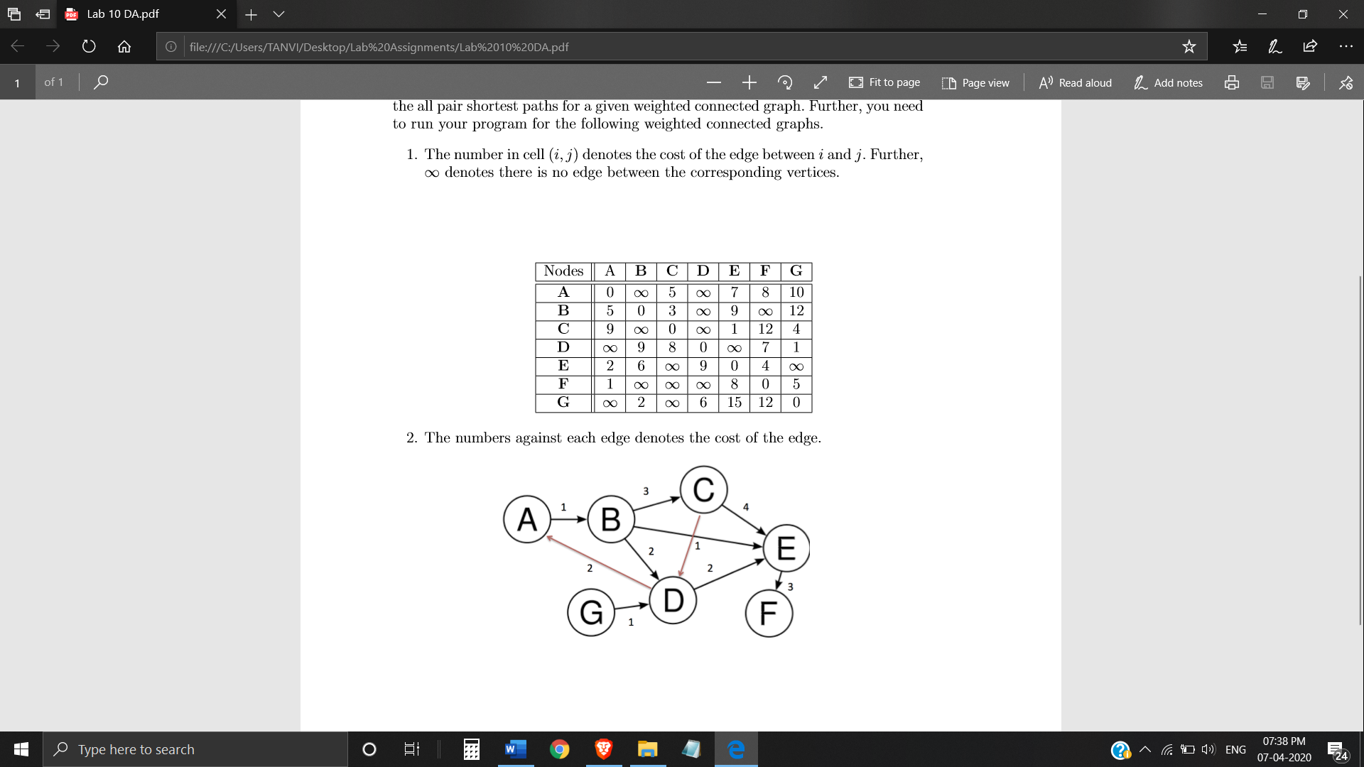

**Implementation:**

import math

inf=math.inf

global V

V=7

def main(ques1):

    d=list(map(lambda i:list(map(lambda j:j,i)),ques1))

    for k in range(V):

        for i in range(V):

            for j in range(V):

                d[i][j]=min(d[i][j],d[i][k]+d[k][j])

    printf(d)

def printf(d):

    for i in range(V):

        for j in range(V):

            if(d[i][j]==inf):

                print("inf",end=" ")

            else:

                print(d[i][j],end="  ")

        print(" ")

ques1=[[0,inf,5,inf,7,8,10],[5,0,3,inf,9,inf,12],[9,inf,0,inf,1,12,4],

       [inf,9,8,0,inf,7,1],[2,6,inf,9,0,4,inf],[1,inf,inf,inf,8,0,5],[inf,2,inf,6,15,12,0]]

main(ques1);

**Output:**

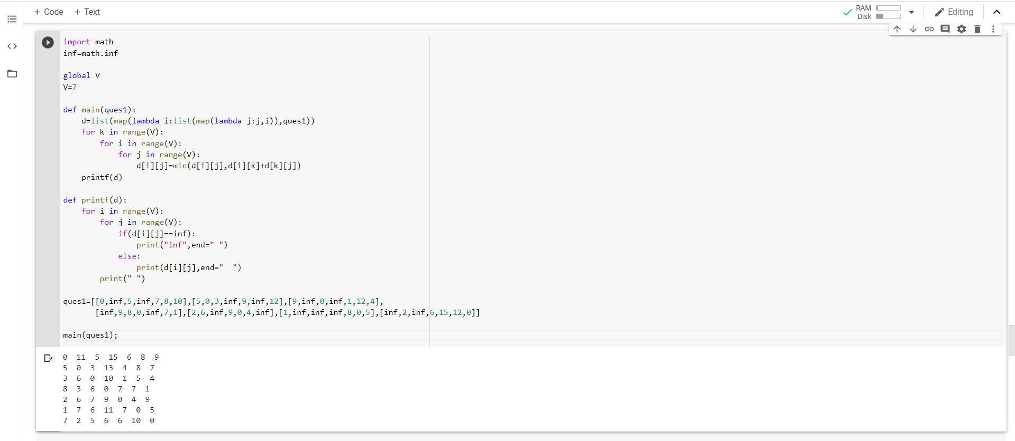

**Question 2:**

The numbers against each edge denotes the cost of the edge.

Given Weighted Directed Graph:



Weighted Directed Graph representation using Adjacency Matrix:

|  |  |  |  |  |  |  |  |
| --- | --- | --- | --- | --- | --- | --- | --- |
| **V** | **A** | **B** | **C** | **D** | **E** | **F** | **G** |
| **A** | 0 | 1 | ∞ | ∞ | ∞ | ∞ | ∞ |
| **B** | ∞ | 0 | 3 | 2 | 1 | ∞ | ∞ |
| **C** | ∞ | ∞ | 0 | 1 | 4 | ∞ | ∞ |
| **D** | 2 | ∞ | ∞ | 0 | 2 | ∞ | ∞ |
| **E** | ∞ | ∞ | ∞ | ∞ | 0 | 3 | ∞ |
| **F** | ∞ | ∞ | ∞ | ∞ | ∞ | 0 | ∞ |
| **G** | ∞ | ∞ | ∞ | 1 | ∞ | ∞ | 0 |

**Implementation:**

import math

inf=math.inf

global V

V=7

def main(ques2):

    d=list(map(lambda i:list(map(lambda j:j,i)),ques2))

    for k in range(V):

        for i in range(V):

            for j in range(V):

                d[i][j]=min(d[i][j],d[i][k]+d[k][j])

    printf(d)

def printf(d):

    for i in range(V):

        for j in range(V):

            if(d[i][j]==inf):

                print("inf",end=" ")

            else:

                print(d[i][j],end="  ")

        print(" ")

ques2=[[0,1,inf,inf,inf,inf,inf],[inf,0,3,2,1,inf,inf],[inf,inf,0,1,4,inf,inf],

       [2,inf,inf,0,2,inf,inf],[inf,inf,inf,inf,0,3,inf],[inf,inf,inf,inf,inf,0,inf],[inf,inf,inf,1,inf,inf,0]]

main(ques2);

**Output:**

